[**BUAN 6320.504 - Database Foundations for Business Analytics - F23**](https://elearning.utdallas.edu/webapps/blackboard/execute/courseMain?course_id=_330166_1)

**Project - Output Report**

**Group #11**

**Hospital Database Management System**

Group Members:

1. Aashay Bhujbal -asb220014
2. Mani Saxena -mxs230066
3. Harsh Kumar Lal Das -hxl220024
4. Karthik Reddy Vuyyuru -kxv230006

**Data Definition Language**

1. Creating the Doctor Table

1. Creating the Patient Table

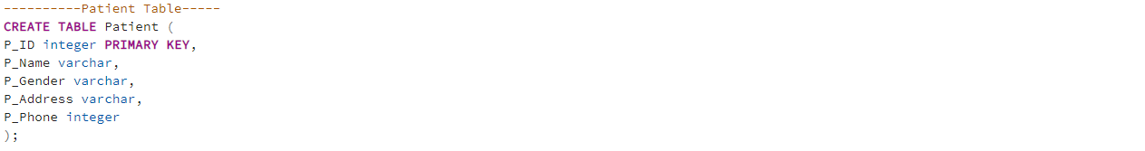

1. Creating the Appointment Table

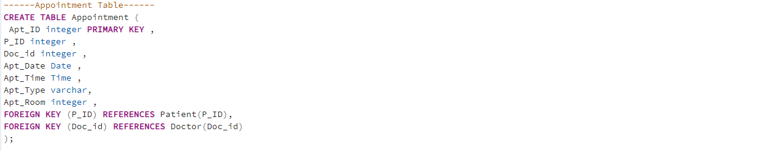

1. Creating the Prescription Table

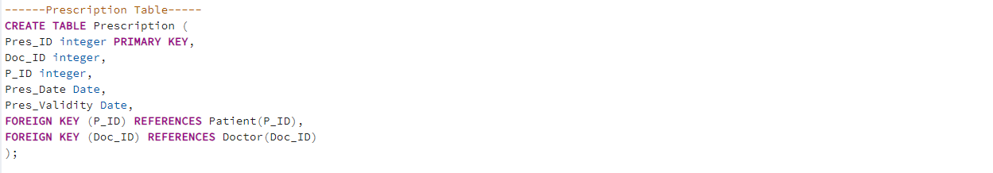

1. Creating the Bill Table

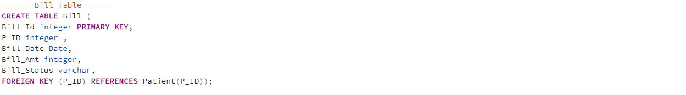

Data Manipulation Language

**DML File**

1. Inserting Data into Doctor Table

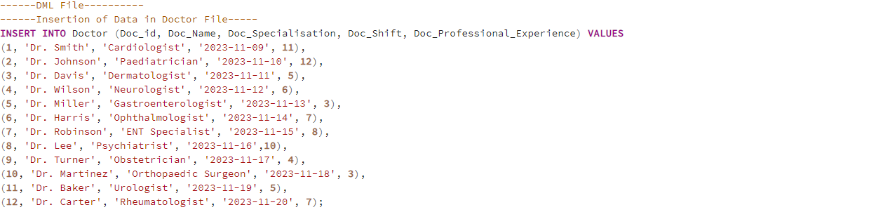

**Result**

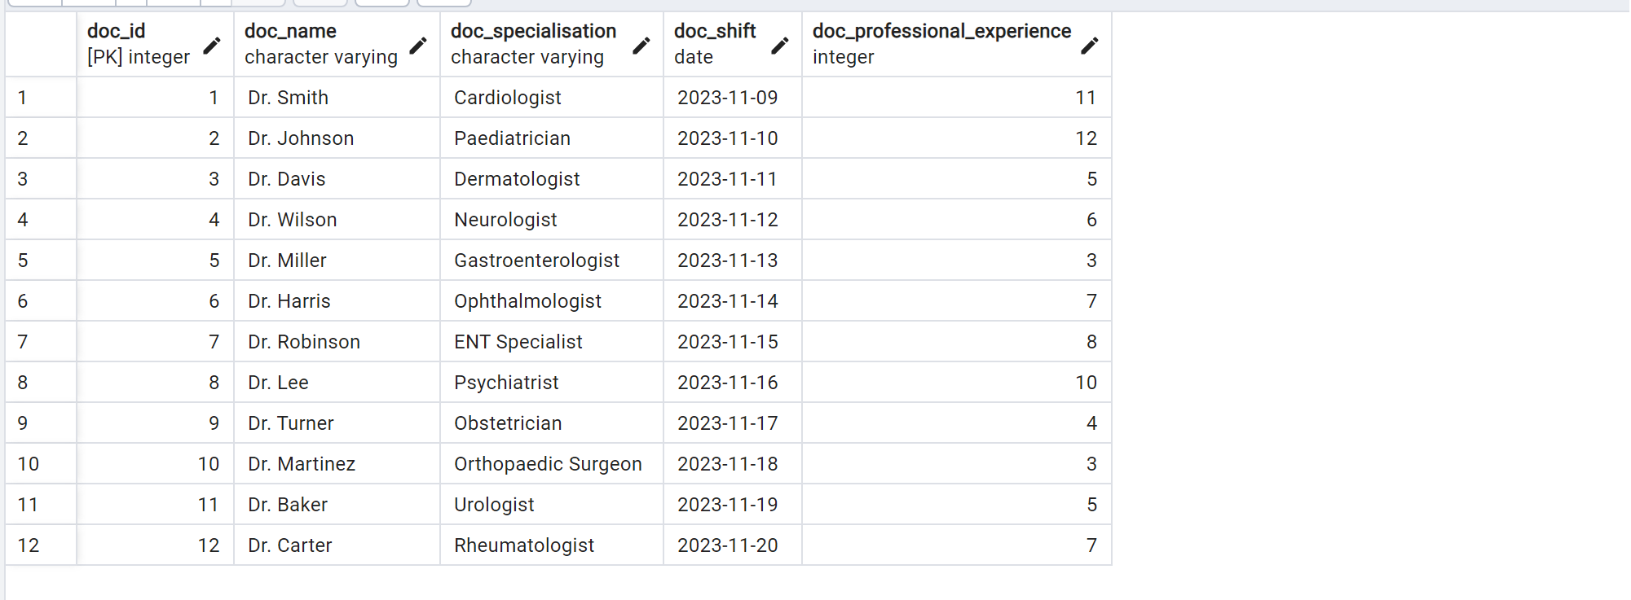

1. Inserting Data into Patient Table

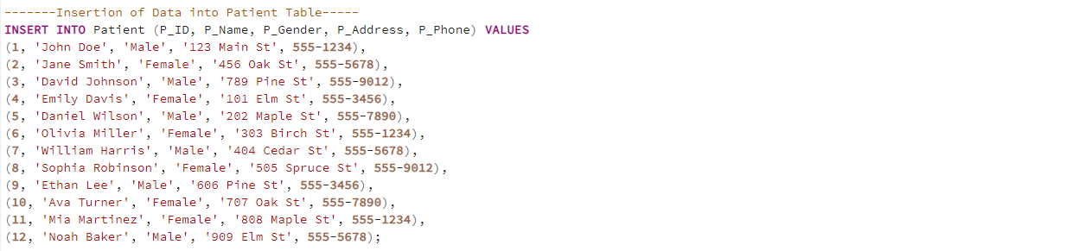

**Result**

1. Inserting Data into the Appointment Table

**Result**

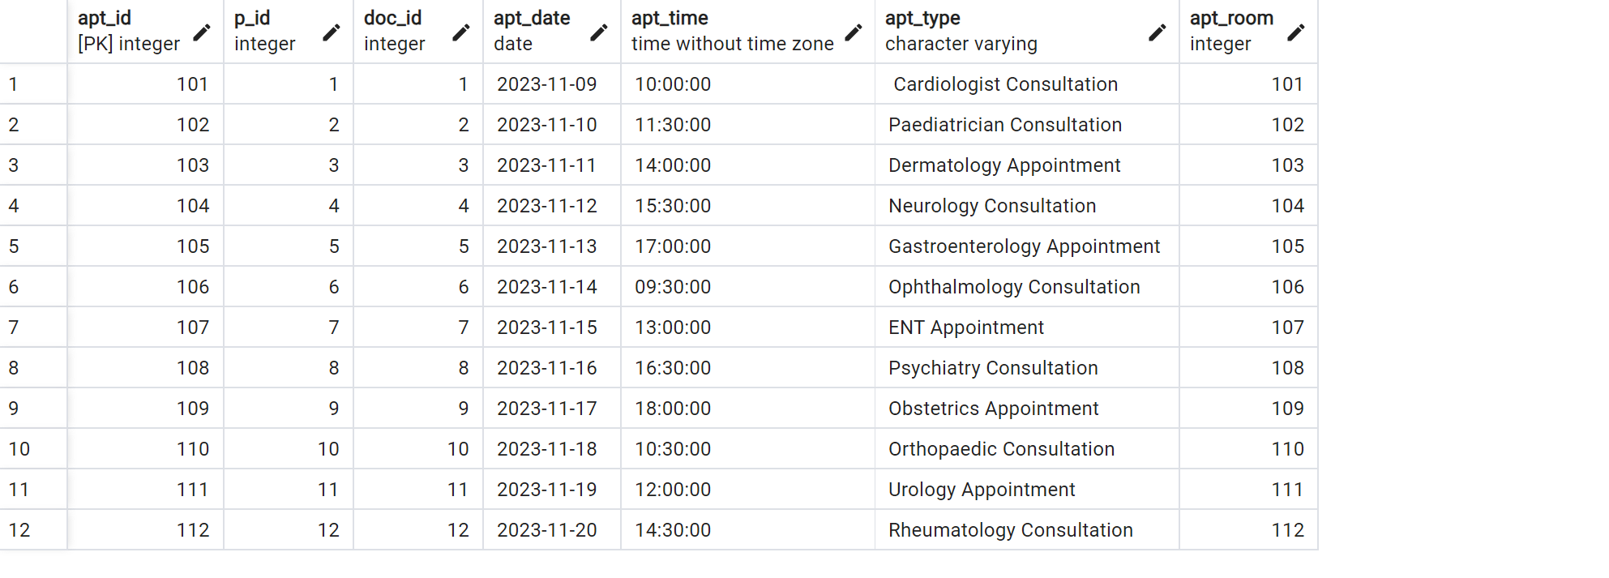

1. Inserting Data into the Prescription Table

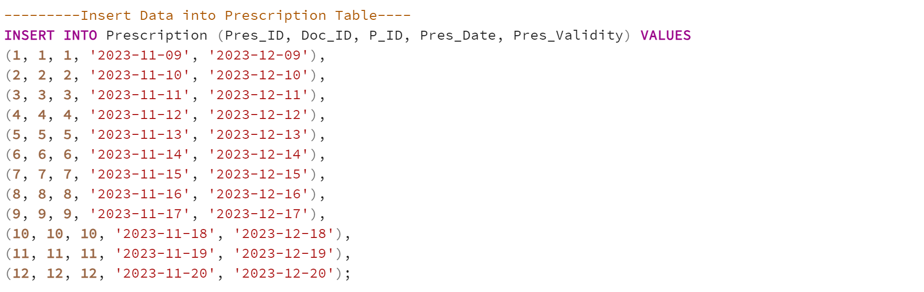

**Result**

5. Inserting Data into the Bill Table

**Result**

**SEQUENCES**

---------Sequence for Doctor id

CREATE SEQUENCE doc_id_seq

INCREMENT BY 1

START WITH 1

MINVALUE 1

NO MAXVALUE

CACHE 1;

---------Sequence for Appointment Id

CREATE SEQUENCE Apt_ID_seq

INCREMENT BY 1

START WITH 1

MINVALUE 1

NO MAXVALUE

CACHE 1;

------Sequence for Patient Id

CREATE SEQUENCE P_ID_seq

INCREMENT BY 1

START WITH 1

MINVALUE 1

NO MAXVALUE

CACHE 1;

--------Sequence for Bill Id

CREATE SEQUENCE Bill_Id_seq

INCREMENT BY 1

START WITH 1

MINVALUE 1

NO MAXVALUE

CACHE 1;

--------Sequence for Prescription Id

CREATE SEQUENCE Pres_Id_seq

INCREMENT BY 1

START WITH 1

MINVALUE 1

NO MAXVALUE

CACHE 1;

**Triggers**

**-- Create a trigger to automatically set doc_id before insert**

**CREATE OR REPLACE FUNCTION set_doc_id()**

**RETURNS TRIGGER AS $$**

**BEGIN**

**- If doc_id is not provided, set it to the next value from the sequence**

**IF NEW.doc_id IS NULL THEN**

**NEW.doc_id := nextval('doc_id_seq');**

**END IF;**

**RETURN NEW;**

**END;**

**-- Attach the trigger to the doctors table**

**CREATE TRIGGER set_doc_id_trigger**

**BEFORE INSERT ON doctors**

**FOR EACH ROW**

**EXECUTE FUNCTION set_doc_id();**

**12 Basic Queries: 2 Advanced Queries**

**Query 1**

1. SELECT * FROM Doctor;

1. SELECT * FROM Patient;

1. SELECT * FROM Appointment;

iv) SELECT * FROM Prescription.

1. SELECT * FROM Bill;

**Query 2**

SELECT

Doc_id,

Doc_Name,

Doc_Specialisation,

Doc_Shift,

Doc_Professional_Experience

FROM Doctor;

SELECT

p_id,

p_name,

p_gender,

p_address,

p_phon

FROM Patient;

SELECT

Apt_ID,

Doc_id,

P_ID,

Apt_Date,

Apt_Time,

Apt_Type

FROM Appointment;

SELECT

Pres_ID,

Doc_ID,

P_ID,

Pres_Date,

Pres_Validity

FROM Prescription;

v)

SELECT

Bill_Id,

P_ID,

Bill_Date,

Bill_Amt,

Bill_Status

FROM Bill;

**Query 3**

CREATE VIEW HealthcareView AS

Select A.Apt_ID,

A.Doc_id as app_Doc_ID,

A.P_ID as app_P_ID,

A.Apt_Date,

A.Apt_Time,

A.Apt_Type,

A.Apt_Room ,

D.Doc_id,

D.Doc_Name,

D.Doc_Specialisation,

D.Doc_Shift,

D.Doc_Professional_Experience,

P.P_ID as patient_ID,

P.P_Name,

P.P_Gender,

P.P_Address,

P.P_Phone ,

PR.Pres_ID,

PR.Doc_ID as Prescription_DOC_ID,

PR.P_ID as prescription_patient_id,

PR.Pres_Date,

PR.Pres_Validity,

B.Bill_Id,

B.P_ID AS bill_Patient_id,

B.Bill_Date,

B.Bill_Amt,

B.Bill_Status

From Appointment A

JOIN Doctor D on D.doc_id = A.doc_id

JOIN Patient P on P.P_ID = A.P_ID

JOIN Prescription PR on (PR.doc_id = A.doc_id and PR.p_id = A.doc_id and PR. Pres_Date = A. Apt_Date)

JOIN bill B on (B. P_ID = A.P_ID AND B.Bill_Date = A. Apt_Date);

SELECT * FROM HealthcareView;

**Result**

**Query 4**

SELECT *

FROM Bill B

Join

Patient P

ON

P.P_ID = B.P_ID;

**Result**

**Query 5**

**SELECT**

**Doc_id,**

**Doc_Name,**

**Doc_Specialisation,**

**Doc_Shift,**

**Doc_Professional_Experience**

**FROM Doctor**

**ORDER BY Doc_Name ASC;**

**Result**

**Query 6**

Select

A.Apt_ID,

D.Doc_id,

P.P_ID,

A.Apt_Date,

A.Apt_Time

FROM Appointment A

Join doctor D on D.DOC_id = A.doc_id

Join Patient P on P.P_ID = A.P_ID

LIMIT 10;

**Query 7**

SELECT DISTINCT *

FROM Prescription P

JOIN Doctor D ON D.Doc_ID = P.Doc_ID

Join Patient PA on PA.P_ID = P.P_ID

**Result**

**Query 8**

SELECT

D.Doc_ID,

D.Doc_Name,

Count(D.Doc_ID)

FROM Doctor D

INNER JOIN Patient P ON P.P_ID = D.Doc_ID

GROUP BY D.Doc_ID, D.Doc_Name

HAVING D.Doc_ID>0

ORDER by D.Doc_ID;

**Query 9**

Select *

From Doctor

Where Doc_ID IN (1,3,5,7,9,11);

**Result**

**Query 10**

Select LENGTH(Doc_ID)

From Doctor;

**Result**

**Query 11**

Select * from bill ;

BEGIN TRANSACTION;

Delete from bill where bill_ID = 1;

Rollback;

Select * from bill;

------Initial Table

----Table after deletion

-----Table after rollback

**Query 12**

SELECT * FROM doctor;

-- Start a transaction

BEGIN TRANSACTION;

-- Update the row with Doc_id = 1

UPDATE doctor

SET Doc_Name = 'Dr. Avnish',

Doc_Specialisation = 'Ophthalmologist',

Doc_Shift = '2023-11-03', -- Assuming 'Doc_Shift' is a date column

Doc_Professional_Experience = 3

WHERE Doc_id = 1;

-- Display the state of the "doctor" table after the update

SELECT * FROM doctor;

-- Rollback the changes made during the transaction

ROLLBACK;

**Result**

UPDATED TABLE

**ADVANCE QUERIES**

**Query 1**

**-----Defining a CTE by the name Patient_List**

WITH Patient_list as

( SELECT

DISTINCT P.P_ID,

P.P_Name,

P.P_Gender,

P.P_Address,

P.P_Phone

FROM

appointment A

JOIN

patient P

ON

P.P_ID = A.P_ID

JOIN

doctor D

ON

D.Doc_ID = A.Doc_ID

WHERE Doc_name LIKE 'Dr. M%')

---List of patient's having appointments with Doctor having first name starting with M

SELECT

DISTINCT

b.P_ID,

PL.P_Name,

PL.P_Gender,

PL.P_Address,

PL.P_Phone,

SUM( CASE WHEN b.bill_status = 'Paid'

THEN

b.Bill_Amt else 0 end ) AS total_paid_amount,

SUM(CASE WHEN b.bill_status = 'Unpaid' then b.Bill_Amt else 0 end)

AS total_unpaid_amount

FROM bill b

JOIN Patient_list PL ON PL.P_ID = B.P_ID

GROUP BY

b.P_ID,

PL.P_Name,

PL.P_Gender,

PL.P_Address,

PL.P_Phone;

**Result:**

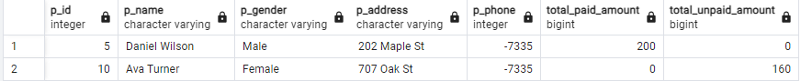

**----Query 2:** Details of doctors who have appointments with patients with maximum and minimum bills.

WITH patient_total_bill as

(SELECT

DISTINCT P_ID,

SUM(bill_amount) as total_bill ,

FROM bill

Group by P_ID ),

max_min_bill as

(SELECT

MAX(total_bill) as max_bill,

MIN(total_bill) as min_bill

FROM patient_total_bill),

Patient_list AS

(SELECT

DISTINCT P_ID

FROM patient_total__bill

WHERE (total_bill = (select max_bill from_max_min_bill)

OR

(total_bill = (select min_bill from_max_min_bill)))

SELECT

DISTINCT D.Doc_id,

D.Doc_Name,

D.Doc_Specialisation,

D.Doc_Shift,

D.Doc_Professional_Experience

FROM Appointment A

JOIN Doctor D on D.doc_id = A.doc_id

WHERE A.P_ID in (select distinct P_ID from patient_list);

